Contents
Project Documentation: Intelligent IoT Kitchen Safety & Surveillance System 2
1. Introduction 2
1.1 Core Objectives 2
2. System Architecture 3
2.1 The Floor Node (Gas Detection Unit) 3
2.2 The Ceiling Node (Main Controller & Environment Unit) 3
2.3 The Visual Node (Surveillance Unit) 3
2.4 The Analysis Node (Cloud Logic & AI) 4
3. Hardware & Circuit Specifications 5
3.1 Connection Topologies 5
3.2 Pin Mapping 5
4. Software Logic & Workflow 6
4.1 The "Invisible Wire" Protocol 6
4.2 Safety Automation Logic 6
4.3 Cloud Analysis Workflow (n8n) 6
5. Database Schema 8
6. User Application (Android) 9
7. Conclusion 10

Project Documentation: Intelligent IoT Kitchen Safety & Surveillance System

1. Introduction
This project, titled "Synapse" (or Smart Kitchen Monitor), is an automated IoT safety system designed to detect hazardous conditions in a kitchen environment—specifically fire, gas leaks, and smoke. The system employs a multi-node architecture separating detection, surveillance, and mitigation into distinct units to ensure reliability and fault tolerance.
To enhance decision-making, the system now incorporates an AI-powered analysis layer. This feature utilizes n8n automation to analyses visual data and stores the results in Firebase, allowing the Android application to display both the image and an intelligent threat assessment to the user.

1.1 Core Objectives
- Real-time Monitoring: Continuous tracking of temperature, humidity, air quality (smoke), and combustible gas levels (LPG).
- Visual Verification: Automated visual evidence capture upon fire detection to allow users to verify threats remotely and rule out false alarms.
- Automated Mitigation: Immediate activation of an exhaust system (DC Motor) to clear toxic fumes or smoke without human intervention.
- Decentralized Logic: Distribution of sensing tasks across "Ceiling" and "Floor" nodes to optimize sensor placement (e.g., LPG is heavier than air, smoke rises).

2. System Architecture
The system is divided into physical sensor nodes and a cloud-based analysis unit that communicate via the Firebase Realtime Database and Supabase.

2.1 The Floor Node (Gas Detection Unit)
- Hardware: ESP8266 Wi-Fi Module.
- Primary Sensor: MQ-6 Gas Sensor (Targeting LPG/Butane).
- Function:
  - Since LPG is heavier than air, this node is placed near the ground.
  - It continuously samples the air for combustible gas.
  - It uploads the raw gas value (lpg_value) and a boolean status (is_critical) to the Firebase cloud.

2.2 The Ceiling Node (Main Controller & Environment Unit)
- Hardware: ESP8266 Wi-Fi Module.
- Sensors:
  - MQ-2: Smoke and General Flammable Gas sensor.
  - DHT22: Digital Temperature and Humidity sensor.
  - Flame Sensor: Infrared (IR) detector for open fire sources.
- Actuator: DC Motor (simulating an exhaust fan) controlled via a transistor circuit.
- Function:
  - Monitors environmental metrics (Temp/Humidity) and fire hazards (Smoke/Flame).
  - Logic Hub: Acts as the central decision-maker by downloading the Floor Node's status from Firebase.
  - If any hazard is detected (Floor Gas, Ceiling Smoke), it triggers the exhaust fan.
  - Trigger: If the Flame Sensor detects fire, it updates the is_fire flag in Firebase to wake up the camera.

2.3 The Visual Node (Surveillance Unit)
- Hardware: ESP32-CAM (AI-Thinker Model).
- Function:
  - Operates in a semi-dormant monitoring loop to conserve bandwidth.
  - Listens specifically for the is_fire flag in Firebase.
  - Action: Upon trigger, it captures a high-resolution image (VGA 640x480) and uploads it to Supabase Storage for retrieval.
  - Reset: It automatically resets the trigger flag to prevent infinite loops.

2.4 The Analysis Node (Cloud Logic & AI)
- Platform: n8n (Workflow Automation Tool).
- Function:
  - Trigger: Activated via Webhook when a capture event occurs.
  - AI Processing: Fetches the latest image from Supabase and processes it using an OpenRouter LLM Chain to interpret the visual data.
  - Reporting: Writes the structured analysis result (e.g., "Confirmed Fire" or "False Alarm") directly to the Firebase Realtime Database. This allows the Android app to fetch the text analysis efficiently without needing a separate connection to the n8n server.

3. Hardware & Circuit Specifications

3.1 Connection Topologies
- Wi-Fi Communication: All nodes connect to a central 2.4GHz Wi-Fi Access Point.
- Cloud Synchronization: Data synchronization occurs via Firebase Realtime Database (RTDB) using JSON objects.
- Image Storage: Heavy media files (Images) are offloaded to Supabase Storage buckets (cam_photos) to bypass Realtime Database size limits.

3.2 Pin Mapping
The following table outlines the hardware connections:

Unit | Component | Pin / GPIO | Type
Ground Node | MQ-6 Gas Sensor | A0 (ADC) | Analog Input
Ceiling Node | MQ-2 Smoke Sensor | A0 (ADC) | Analog Input
Ceiling Node | DHT22 Sensor | D2 (GPIO 4) | Digital Input
Ceiling Node | Flame Sensor | D1 (GPIO 5) | Digital Input
Ceiling Node | Exhaust Motor | D6 (GPIO 12) | Digital Output (PWM)
Camera Node | Camera Module | Standard Pins | Parallel Interface

4. Software Logic & Workflow

4.1 The "Invisible Wire" Protocol
The system uses a cloud-based boolean flag to link physically separate devices:
- Event: Ceiling Node detects Fire (Flame Sensor == LOW).
- Upload: Ceiling Node sets /kitchen/ceiling/is_fire = true in Firebase.
- Reaction: Camera Node detects the change in is_fire.
- Capture: Camera Node captures an image and performs an HTTP POST request to Supabase.
- Reset: Camera Node sets /kitchen/ceiling/is_fire = false to acknowledge handling.

4.2 Safety Automation Logic
The Exhaust Fan activation logic is an OR gate operation:
Fan Status = (Floor Gas Critical) OR (Ceiling Smoke Critical)
If any of these conditions are true, the motor activates (HIGH) to ventilate the area.

4.3 Cloud Analysis Workflow (n8n)
To distinguish between false alarms and actual fire, the system uses an automated cloud workflow powered by n8n. This workflow runs independently of the hardware nodes.
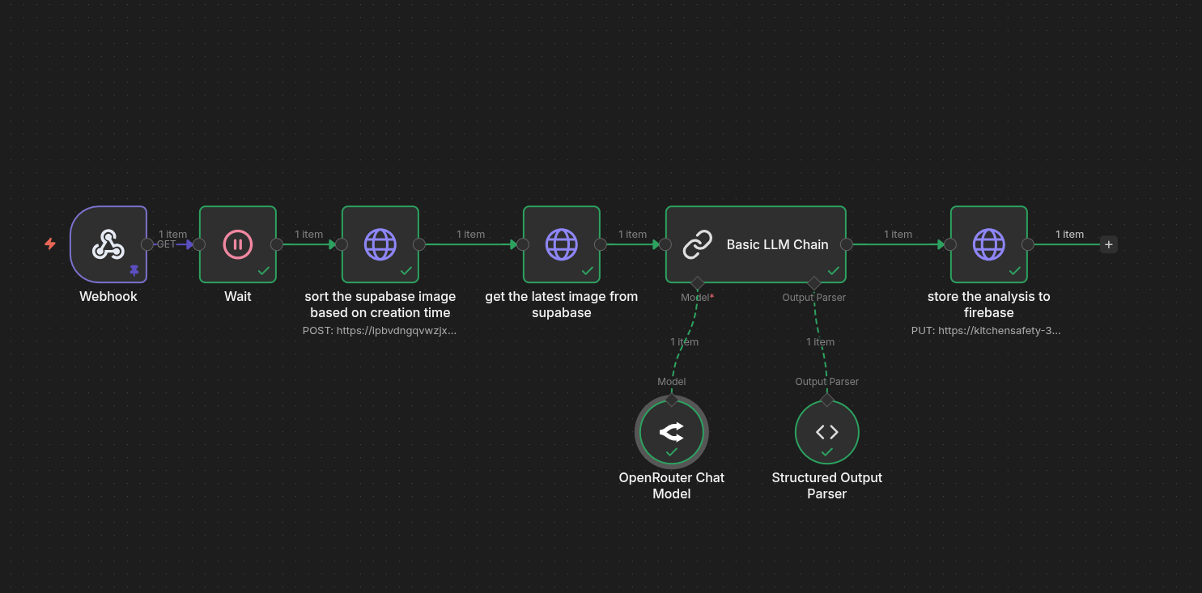
Figure 4.3: n8n Automation Workflow for AI Image Analysis

Workflow Steps:
- Webhook Trigger: The workflow initiates via a Webhook node when the capture event occurs.
- Buffer Delay (Wait Node): A short delay (5 seconds) is introduced to ensure the image has fully finished uploading to Supabase Storage before retrieval attempts.
- Image Retrieval: The workflow performs HTTP requests to sort the Supabase storage bucket by creation time and fetch the most recent image URL.
- AI Processing (Basic LLM Chain): The image is passed to a Basic LLM Chain node.
  - Model: It utilizes the OpenRouter Chat Model to interpret the visual data.
  - Parser: A Structured Output Parser formats the AI's raw text into a clean JSON object.
- Database Sync: Finally, an HTTP Request node sends the structured analysis directly to Firebase, where the Android app listens for updates.

5. Database Schema
The data is structured in a JSON tree within Firebase Realtime Database. The schema includes the sensor data and the new AI analysis section.

JSON
{
"kitchen": {
"ceiling": {
"temperature": 28.5,
"humidity": 60.2,
"smoke_level": 12,
"is_fire": false, // Trigger for Camera
"fan_status": false // Feedback for App
},
"floor": {
"lpg_value": 350,
"is_critical": false // Trigger for Fan
},
"analysis": { // New Section for AI Reporting
"latest_result": "Visual confirmation: Fire detected.",
"timestamp": 1767452613581
}
}
}

6. User Application (Android)
The mobile application (Android) serves as the primary interface for the system, featuring the following implementations:
- Dashboard: Live visualization of temperature, humidity, and air quality.
- Push Notifications: Alerts for "Critical Gas Leak" or "Fire Detected".
- Smart Evidence Viewer:
  - Image: Fetches the evidence URL from Supabase to show the snapshot taken during the alarm.
  - AI Insight: Simultaneously fetches the "latest_result" from Firebase to display the AI's interpretation of the scene (e.g., "Safe" vs "Danger"), helping the user react faster.
- Manual Override: A button to remotely turn off the alarm/fan if false detection occurs.

7. Conclusion
The Synapse project successfully demonstrates the effectiveness of a decentralized, multi-node IoT architecture in addressing kitchen safety hazards. By strategically placing the Floor Node for heavy gas detection and the Ceiling Node for smoke and fire, the system ensures optimal sensitivity for diverse threats.
The integration of the n8n AI Analysis Node marks a significant advancement over traditional safety systems. By coupling real-time sensor data with intelligent visual analysis, the system not only automates mitigation via the exhaust fan but also empowers users with verified, context-aware information. This "Human-in-the-Loop" approach, facilitated by the Android application, drastically reduces the panic associated with false alarms and provides a robust, scalable solution for modern smart home safety.

